Low Level Design (SEARCH PRODUCT MODULE)

Project Code | Team1
Project Name | E-Commerce(Online Shopping)

Prepared/Modified by | Role | Date of Preparation
Bhagyashree Vedapthak | Software Engineer | 16/12/2013
Reviewed by | Role | Date of Review
Shrikant Sutar | Software Engineer | 17/12/2013
Approved by | Role | Date of Approval
Uma M Ponniamman | Training Manager
Circulation List | amit.agarwal@igate.com, mrunalee.kothari@igate.com, keerthi.parthasarathy@igate.com, nidhi.shetty@igate.com, nikeeta.menon@igate.com, shrikant.sutar@igate.com, bhagyashree.vedpathak@igate.com | Version Number of the template:1.0
Version Number | 1.4

Table of Contents

1. Description Of The Unit 3
2. References 4
3. Dependencies / Assumptions 5
4. Class Diagrams 6
5. Sequence Diagrams 7
6. Design Components 8
6.1 List Of UI Components 8
6.2 List Of Design Classes 8
7. Re-Usable Routines/Components 9
8. Messages 10
9. Configuration Files 11
10. Crud Matrix Table 12
11. Data Mapping Matrix 13
12. Action Flow Matrix 14
13. Stored Procedures 15
14. Program Specification / Pseudo Code 16
REVISION HISTORY OF THE WORK PRODUCT 17

Description Of The Unit

The search module is used by users to get the product details. The user can be visitor, customer, administrator or sales manager.This module searches for the product and displays it on mainscreen.

References

Reference | Description
Repository reference | https://IGTEBLRSVNTNG.igatecorp.com/svn/oct3_Team1
Class Diagram | /Project Documents/Design Documents/HLD/Class Diagrams
URS | /Project Documents/Requirements/Case Study/Ecommerce-grp1 and grp3.doc
UTP | /Project Documents/Test Plan/UTP/Test Cases/Search Module
DB Design | /Project Documents/Design Documents/HLD/DB Design/E-Commerce_GROUP_DBDESIGN.xls

Dependencies / Assumptions

Assumptions:

Database should have the details of that product stored in it.

Class Diagrams

Class Diagram

Sequence Diagrams

Sequence Diagram
NA

Design Components

List Of UI Components

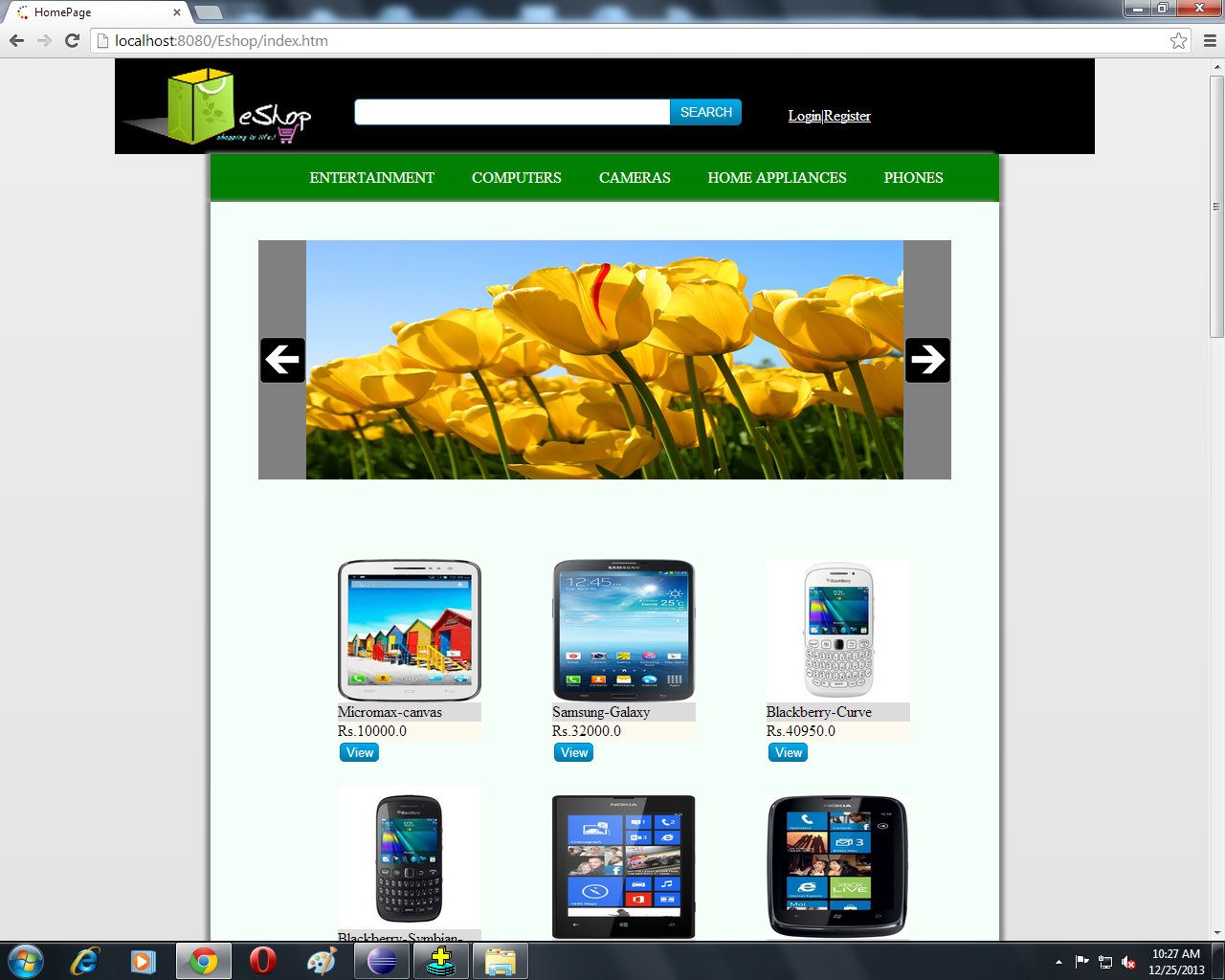

List Of Design Classes

Sr. No. | LLD Name | Class Name | Method Name | Method Description
1 | Search Module | Product (Java Bean) | Appropriate getters and setters methods | Getters retrieve the property values and setters set the property values
2 | Search Module | EshopController | searchProductDetails(@RequestParam(value="productName") String productName ) :String | Searches the details of product name entered in a text box.
3 | Search Module | EshopBOImpl | getProductDetailsByName(productName:String):List<Order> | Gets product details and stores it in a list and returns it to controller
4 | Search Module | EshopDAOImpl | getProductDetailsByName(productName:String):List<Order> | Gets product details and stores it in a list and returns it to EshopBOImpl

Re-Usable Routines/Components

Re-Usable Routines/Components

- CSS files
- Javascript files
- DataAccessException class
- Database properties files
- Logger properties files

Messages

#. | Type | Message Text
M1 | Information | No Such Item Found

Configuration Files

File Name | Path | Description
oracle.properties | /Development/Source | To configure database connection.
Web.xml | /Development/Source | To configure the bean properties.
Dispatcher-servlet.xml | /Development/Source | To configure the request mapping and view resolver.
Eshop_logger.properties | /Development/Source | To configure the logger.
Eshop_error.properties | /Development/Source | To configure error messages.

Crud Matrix Table

# | Table Name | Create | Read | Update | Delete
1 | Product | N | Y | N | N
2. | ProductImage | N | Y | N | N

Data Mapping Matrix

Sr. No. | Screen Label | Field Source | Field Type | Data Type | Max Length | Data Flow | Mandatory
1 | Search | product.product_name | TextField | Varchar2 | 50 | UI | NA
2 | Search | NA | Button | NA | NA | UI | NA

Legend
D → UI (Database to User Interface)
UI → D (User Interface to Database)
UI (User Interface Only)

Action Flow Matrix

Sr. No. | Action | Description | Process
1 | On click of  ‘Search’ Button | Displays product details | Details of product entered in text box are displayed on the home screen.

Stored Procedures

# | Stored Procedure Name  (with Description) | Input/Out Parameters | Type | Size
1. | NA | NA | NA | NA

Program Specification / Pseudo Code

14.1 <ACTION: SEARCH_CLICK>

Pseudo Code:
- Client Side Scripting:
None
- Server Side Scripting:
IF invalid characters entered
Print Info Message M1.

BEGIN
Call searchProductDetails(@RequestParam(value="productName")String productName,Model model) in presentation layer
BEGIN
Call getProductDetailsByName(String productName) in EcommerceBoImpl in service layer
BEGIN
Call getProductDetailsByName(String productName) in EcommerceDaoImpl in database layer
BEGIN
Create query for retrieving details from Product and ProductImage table
Return product details and returns a list
END
Return product details and returns a list to Service Layer
END
Return product details and returns a list to Presentation Layer
END
REVISION HISTORY OF THE WORK PRODUCT

# | Date | Version # | Section Changed | Details of changes made | Approved By
1 | 16/12/2013 | 1.0 | NA | NA | Uma M Ponniamman
2 | 17/12/2013 | 1.1 | List of design classes. | Name of controller is modified to “EshopControleer”. | Uma M Ponniamman
3 | 18/12/2013 | 1.2 | Reusable components,  References,  Data Mapping Matrix. | Reusable Components added.  File name with relative path is added in the references section.  The name of text boxes(screen label is changed). | Uma M Ponniamman
4 | 20/12/2013 | 1.3 | List of design classes, program specification | Signature of classes modified. | Uma M Ponniamman
5 | 24/12/2013 | 1.4 | Configuration files,UI Components | Paths of the configuration files is updated and UI components(Screen Shots) added. | Uma M Ponniamman

